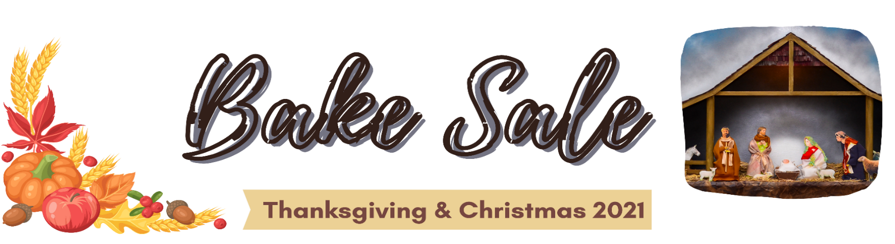
ITEM | DESCRIPTION | PACKAGE SIZE |  | PACKAGE  PRICE |  | QTY | TOTAL PRICE
Fatayer | Spinach Pies | Dozen |  | $ 16.00
Sfiha | Open Face Meat Pies | Dozen |  | $18.00
Sambousek | Fried meat pie | Dozen |  | $18.00
Mana’eesh w/Za’atar | Pizza w.oregano  & sesame seeds | 1/2 Dozen |  | $10.00
Mana’eesh w/Cheese | Pizza with cheese | 1/2 Dozen |  | $12.00
Kibbe ‘Rass - Frozen | Crushed wheat mixture w.meat mix stuffed w.meat | Dozen |  | $20.00
Kibbeh bilsaniye | Crushed wheat w.meat mix stuffed with meat | 1/2 Sheet |  | $30.00
Shish Barak | Stuffed dough w.meat | 2 Dozen |  | $20.00
Warak a-arish (veggie) | Veggie stuffed grape leaves | 2 Dozen |  | $20.00
Sablet Cookies | Cookies with jam | Dozen |  | $18.00
Sha’aybiyet | Phyllo dough w.custard stuffing | 1/2 Dozen |  | $12.00
Nammoura | Semolina cake | 1/2 Dozen |  | $12.00
Ka’ak btammer | Cookies with dates | Dozen |  | $20.00
Ka’ak bhalib | Milk based cookies | Dozen |  | $15.00
Ka’ak Yansoon | Yansoon (anise) based cookies | Dozen |  | $15.00
Arak | Arak | 1 bottle | Case | $35 | $360
Ksara Wine | Red/White Wine | 1 bottle | Case | $30 | $300
Almaza Beer | Beer | 6-pack | Case | $12 | $40
Add your item, here:
TOTAL | TOTAL

Last Order Date |  | Curbside Pickup Date
Thanksgiving | Tuesday, Nov. 16th | Saturday/Sunday, Nov. 20/21
Christmas | Friday, Dec. 10th | Saturday/Sunday, Dec. 18/19
Kindly pay and place your order no later than Last Order Date, above Online ordering: www.ollchicago.org
Make checks payable to:
Our Lady of Lebanon Church | Name:
950 N. Grace Street  Lombard, IL 60148 | Phone:

