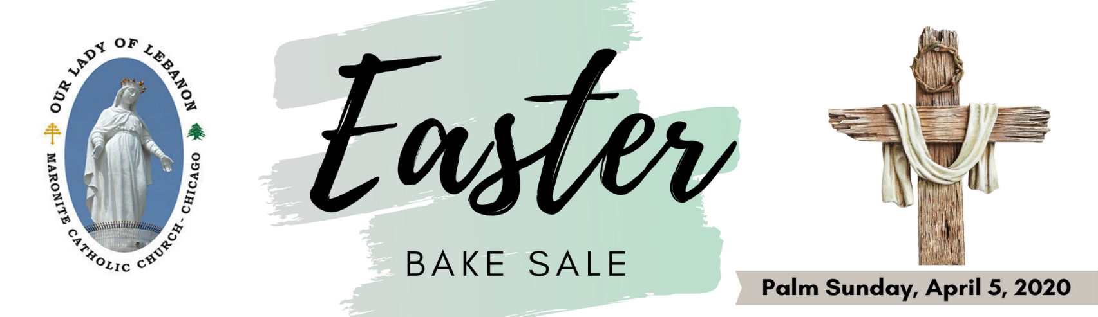
ITEM | PACKAGE SIZE | PRICE PER  PACKAGE | QUANTITY | TOTAL PRICE
Manakeesh with Za'atar | 1/2 Dozen | $ 8.00
Manakeesh with Cheese | 1/2 Dozen | $10.00
Spinach Pies | 1 Dozen | $13.00
Meat Pies | 1 Dozen | $15.00
Kibbe Meatballs | 1 Dozen | $18.00
Veggie Kibbe | 1 Dozen | $18.00
Shishbarak (pre-order only) | 2 Dozen | $15.00
Kibbe Sayniye (pre-order only) | Half Tray | $30.00
Grape Leaves (pre-order only) | 2 Dozen | $15.00
Sha’aybiyet (pre-order only) | 1 Dozen | $10.00
Ma’amoul w/Walnuts | 1 Dozen | $15.00
Ma’amoul w/Pistachios | 1 Dozen | $16.00
Ma’amoul w/Dates | 1 Dozen | $15.00
Sablet Cookies | 1 Dozen | $12.00
Ka'ak Bhalib | 16 oz./1 pound | $12.00
Nammoura | 1 Dozen | $10.00
Indicate your special order, here:
TOTAL
This price is only for Pre-orders.
Kindly pay and place your order no later than April 1th, 2020.
All items pre-orders to be picked up at the church on Palm Sunday: Sunday April 5th, 2020.
Name: ___________________________________
Phone: ___________________________________
Make checks payable to: Our Lady of Lebanon Church; 950 N. Grace Street; Lombard, IL 60148
Online ordering: www.ollchicago.org

